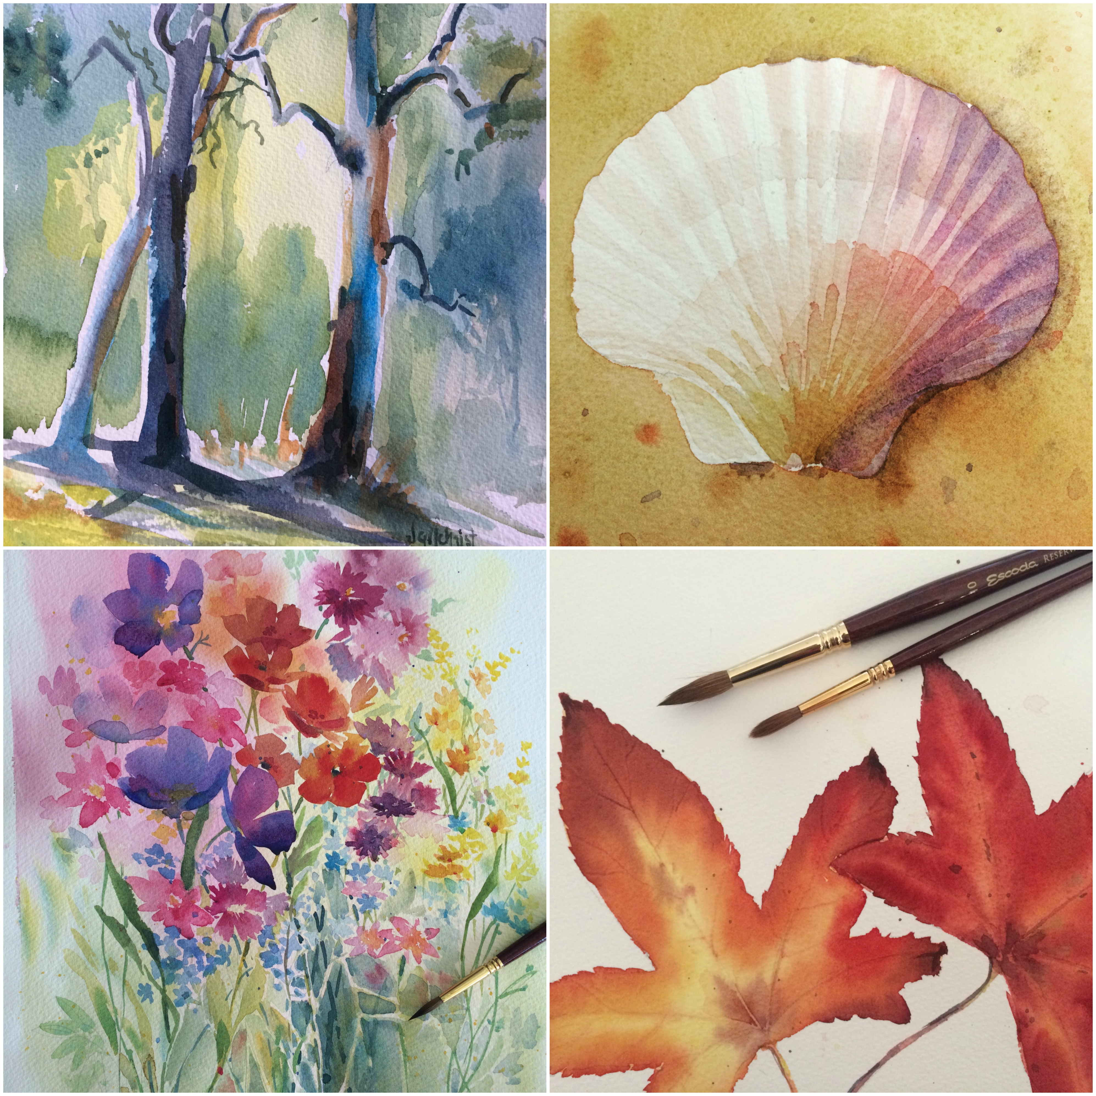 Northern Beaches
Watercolour
Painting Classes

Absolute Beginners-Intermediate
Adult Watercolour classes
Online or Zoom Classes JOIN US!
- Teaching you how to paint, not how to copy.
- Online Anytime – start and paint when you like
- Or Zoom classes live with a great fun group
- Structured Class with fun subjects
- Personal step by step instructions
- Full demonstrations of EVERYTHING.
- 2.5 hour class relaxed and enjoyable
- Experienced tutor and painter of 25 years.
CONTACT AND ALL BOOKING INFORMATION:
Website: www.northernbeacheswatercolour.com.au
Email: northernbeacheswatercolour@outlook.com.au

